American International University-Bangladesh



COMPUTER GRAPHICS

Spring Semester 2023-24

**Project Report  
Evolution of Dhaka City (2000-2030)**

**Course Instructor**

**Aneem Al Ahsan Rupai**

**Lecturer**

**Department of Computer Science, FST**

**Name: Khushbu Alam Rahi**

**ID: 22-46947-1**

**Section: D**

**Table of Contents:**

|  |  |
| --- | --- |
| Topic | Page Number |
| Introduction | 3 |
| Project Graph | 3 |
| List of Objects | 4 |
| List of Functions (Represent Object) | 5 |
| List of Animation Function | 6 |
| Output Screenshot | 7-8 |
| Conclusion | 9 |

**Introduction:**

The year 2030 marks a significant milestone in Dhaka's evolution, reflecting two decades of transformative development. By 2030, Dhaka has emerged as a dynamic metropolis, blending modernity with rich cultural heritage. The skyline features state-of-the-art skyscrapers and green spaces, showcasing a commitment to sustainable growth. Advanced transportation systems, including electric buses, metro lines, and smart traffic management, have enhanced mobility and quality of life. Technological innovations have made Dhaka a smart city with digital connectivity and smart infrastructure. The diversified economy thrives on traditional industries and new sectors like IT, renewable energy, and creative industries. Social advancements in education, healthcare, and public services ensure inclusive development. This project, "The Evolution of Dhaka City: From 2000 to 2030," explores the critical developments, challenges overcome, and visionary plans that have shaped Dhaka into a 21st-century beacon of progress.

**Project Graph:**

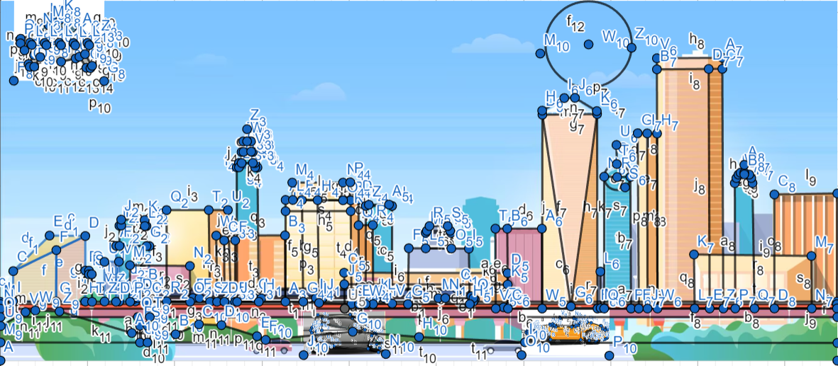

**List of Objects:**

|  |  |  |
| --- | --- | --- |
| SL# | OBJECT ID | OBJECT NAME |
|  | Building-(1-20) | b(1-20) |
|  | Bullet Train | train |
|  | Metro boundary line | metro _rail boundary |
|  | Metro Pillar | metro_pillar |
|  | UFO | ufo |
|  | Sky | sky |
|  | Sun | sky |
|  | Moon | sky |
|  | Background | background |
|  | Tree | tree |
|  | Lamp Post | lamp_stand |
|  | Road | road |
|  | Car | car, car1 |
|  | Day | sky |
|  | Night | sky |
|  | Snow | generateSnow |

**List of Functions:**

|  |  |  |
| --- | --- | --- |
| SL# | OBJECT ID | FUNCTION NAME |
|  | Building-(1-20) | b 1-20() |
|  | Bullet Train | train() |
|  | Metro boundary line | metro _rail boundary() |
|  | Metro Pillar | metro_pillar() |
|  | UFO | ufo() |
|  | Sky | sky() |
|  | Sun | sky() |
|  | Moon | sky() |
|  | Background | background() |
|  | Tree | tree() |
|  | Lamp Post | lamp_stand() |
|  | Road | road() |
|  | Car | car(), car1() |
|  | Day | Sky() |
|  | Night | sky() |
|  | Snow | generateSnow() |

**List of Animation Functions:**

|  |  |  |  |
| --- | --- | --- | --- |
| SL# | Animation Function ID | Animation Function | Object/ Scene |
| 1 | Animation Function 01 | Car,1() | Car |
| 2 | Animation Function 02 | train() | Bullet Train |
| 3 | Animation Function 03 | Headlight() | Car |
| 4 | Animation Function 04 | lamp() | Lamp Stand |
| 5 | Animation Function 05 | handleKeypress() | ufo |
| 6 | Animation Function 06 | sky() | Day-Night |
| 7 | Animation Function 07 | generateSnow() | Snow |

**Output Screenshot:**

**Day Scenario:**



**Night Scenario:**

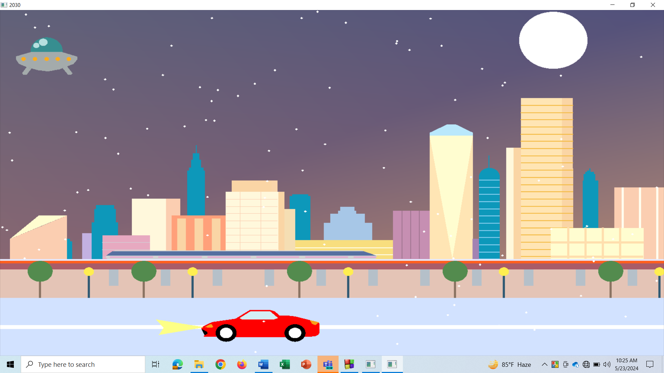

**Conclusion:**

In conclusion, this project, "The Evolution of Dhaka City: From 2000 to 2030," effectively shows the transformation of Dhaka city through the years using specialized code in OpenGL and C++. This transcends static displays, transforming imaginative ideas into a tangible digital reality. Users can shape movement and activities within the scenario, creating an immersive and enjoyable experience. This digital creation not only highlights the critical developments, challenges overcome, and visionary plans that have shaped Dhaka into a 21st-century beacon of progress but also demonstrates the practical application of coding in solving real-world problems. By turning the digital environment into a fun and interactive playground, the project underscores the successful integration of urban planning and technological innovation in fostering **a more sustainable, livable, and dynamic Dhaka.**